User Acceptance Testing (UAT) Template
Date | 17 February 2026
Team ID | LTVIP2026TMIDS87521
Project Name | Rising Waters: A Machine Learning Approach to Flood Prediction
Maximum Marks | 4 Marks

Project Overview:
Let’s see how our home.html page looks like:
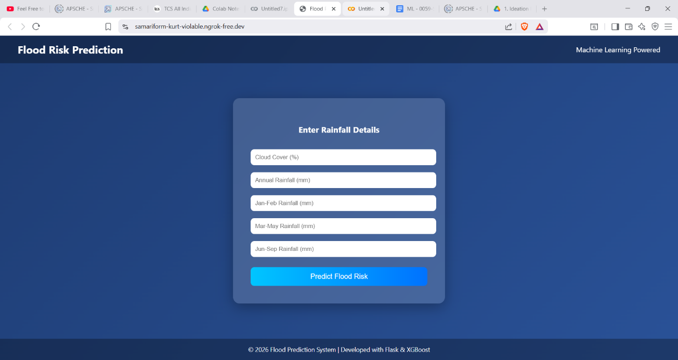
Now when you click on \Predict Flood button from top right corner you will get redirected to predict.html
Lets look how our predict.html file looks like:
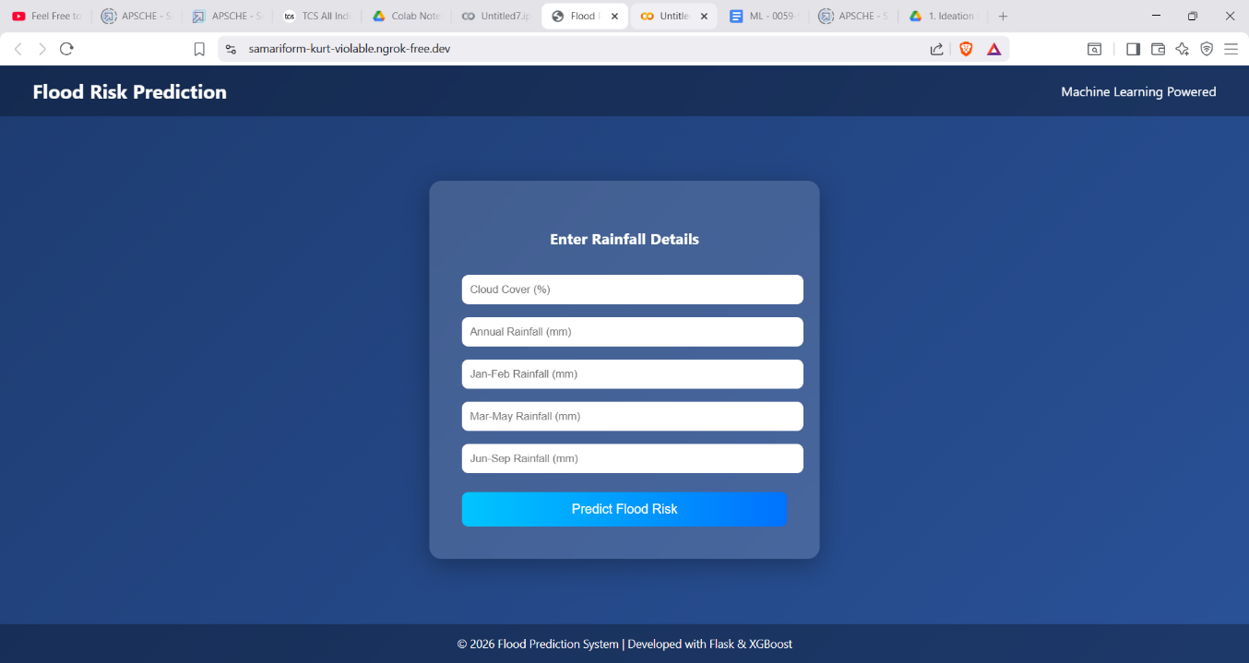
Now when you click on detect button a popup will shown weather the Flood is Expected or Not based on the entered Data.
Lets look how our Pop up looks like:
